Answer 8
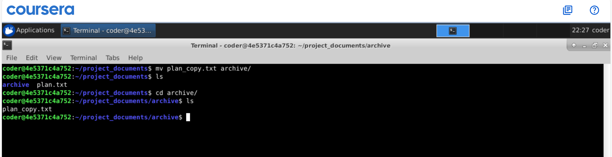
Explanation: Using mv command we can move a file from one directory to another that what I did with plan_copy.txt and it gives desired output.

